Impact of Running a Container on System Resources
Running a Docker container has a relatively light impact on system resources compared to full virtual machines because containers share the host OS kernel rather than running a separate OS. When you start a container:
- CPU Usage: The container uses CPU cycles only when the application inside is active. Idle containers consume minimal CPU.
- Memory Usage: Containers allocate memory from the host system dynamically. A small container like hello-world uses very little RAM, but larger containers with active processes can consume more.
- Disk I/O and Storage: Containers use the host filesystem via layered images. Writing data increases disk usage but does not require a full separate virtual disk.
- Startup Overhead: Containers start almost instantly with negligible overhead, unlike VMs which need to boot an entire OS.
Overall, containers provide lightweight isolation, making them efficient in terms of CPU, memory, and storage, with the main resource impact coming from the processes running inside them rather than the container itself.

PROOF:

Running Docker Process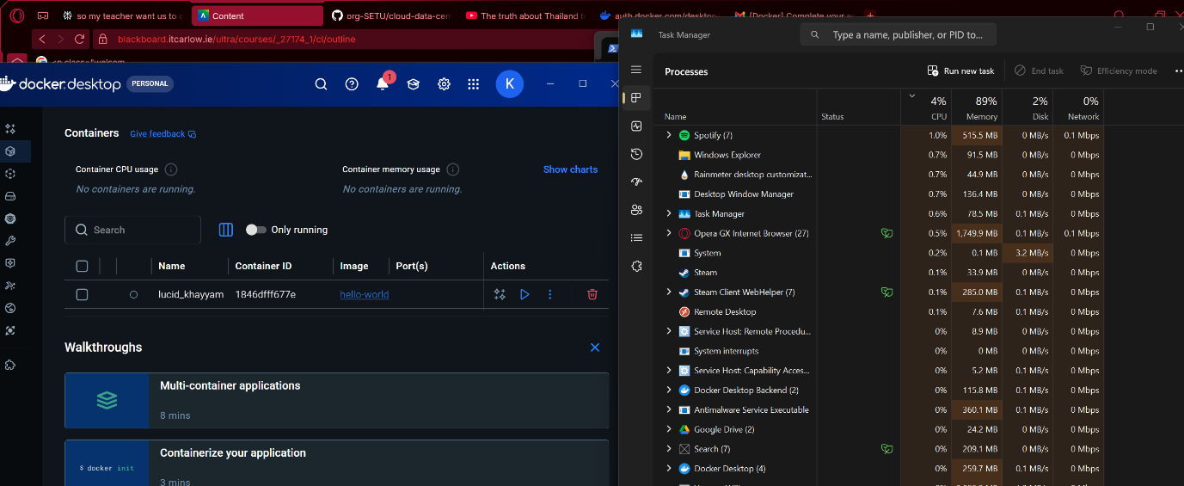
Hello From Docker
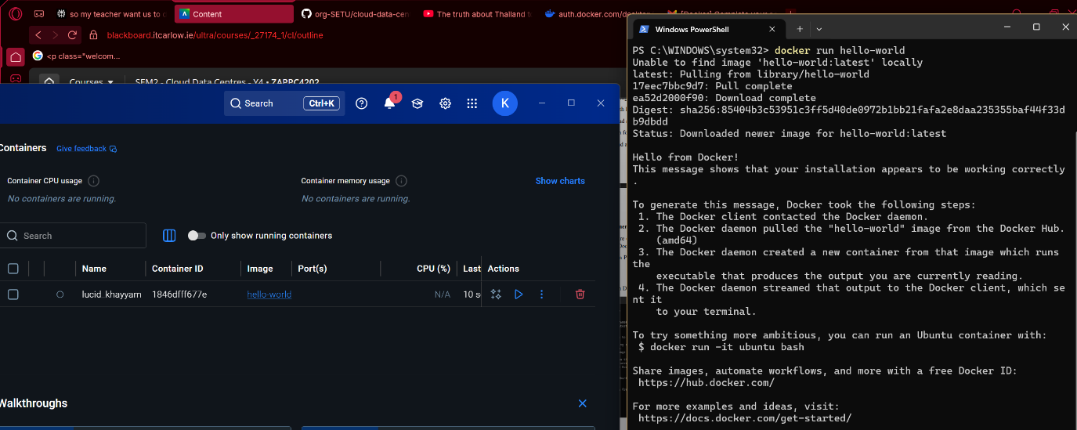

All The hardware information down below
